Benchmark - Project 3: Your Surrounding World

CST-310 Computer Graphics

Angel Velazquez, Kyler Harden

September 22, 2024

Part 2 Documentation:

Description:

In this project we are choosing two scenes from the world around us. For these scenes we will take three pictures from different camera angles and we will for a latter project be assigned to recreate the scene utilizing opengl and c++.

Scene 1:

Scene 1 is of my dog’s kennel. She loves to hoard toys inside her kennel so I decided to use this as the scene as it has a black background with not too much texture and the toys she is hording shouldn’t be too difficult to recreate except for the textures.

Top left Isometric:

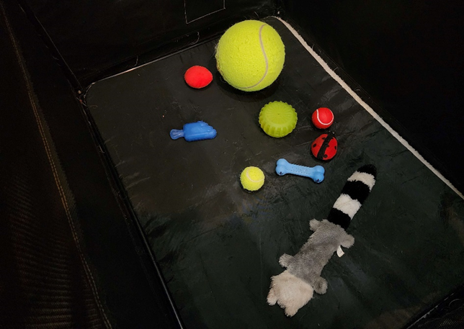

Top right Isometric:

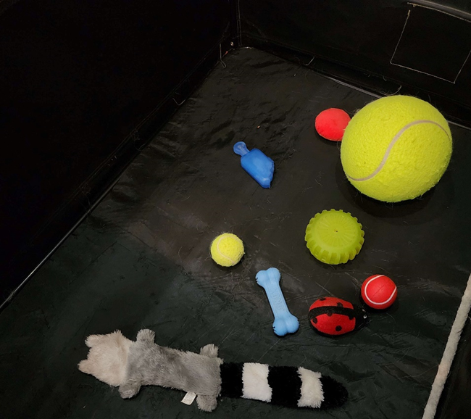

Straight on

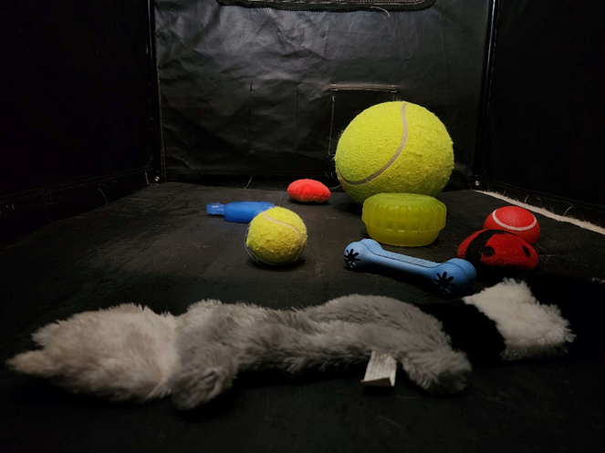

Scene 2:

For this scene, we decided to go with a TV stand with various items ranging from straight to curved lines. I believe this will be a challenging image to portray in openGL while still maintaining a clean look.

Straight on:

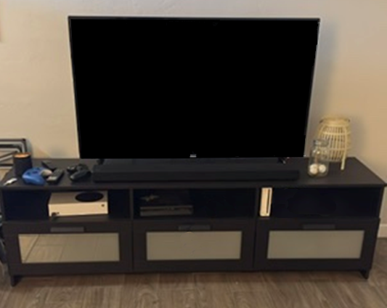

Scewed left:

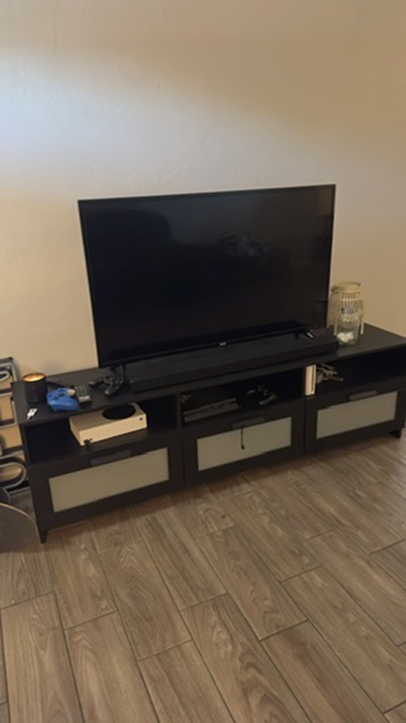

Skewed right:

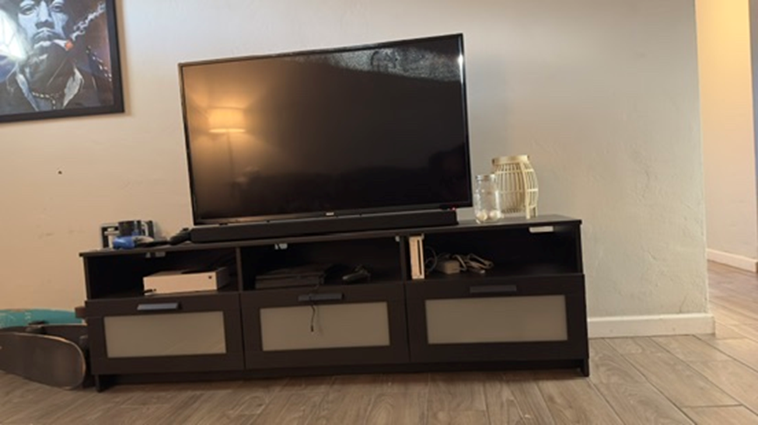

Assigned Image:



List the objects in the foreground, background, and in-between.

* 1. Foreground
     1. Speaker
     2. TV
     3. Xbox
     4. PS4
     5. WII
     6. Remote
     7. Candle
     8. TV stand
     9. Batteries
     10. Ping pong balls
     11. Lantern
     12. Floor
     13. Wall
  2. Background

Main Objects of Scene

* 1. TV stand, TV, Xbox, PS4, Wii

Key Characteristics of the scene

* 1. Cozy and organized entertainment area. The focal point is a large TV. The ambient lighting is soft and warm, which suggests a lamp is somewhere in this room. This contributes to the comfortable and relaxed atmosphere.

How the Shapes would be rendered:

* 1. TV
     1. Shape: then rectangular cuboid
     2. Dimensions: flat and wide, with a very shallow depth to mimic the slip profile of modern TV’s.
  2. Gaming consoles
     1. Shape: small, thin rectangular cuboids
     2. Dimensions: slim and compact, slightly smaller than the compartments in the TV stand
     3. Placement: within one of the compartments or on top of the TV stand
  3. Game Controllers
     1. Shape: flattened, rounded ellipsoids
     2. Dimensions: small, to fit within the hands, with slight curves to suggest handles
     3. Placement: on the surface of the TV stand, near the gaming console
  4. Candle
     1. Shape: small cylinders or spheres.
     2. Placement: next to the lamp, in a small cluster or group to suggest a decorative arrangement
  5. TV stand
     1. Main body
        1. Shape: a long rectangular cuboid
        2. Dimensions: longer and shorter in height
        3. Placement: on the floor, beneath the TV
     2. Drawers/Compartments
        1. Shape: smaller rectangular cuboids
        2. Placement: aligned within the main body of the stand, equally spaced to represent storage compartments
  6. Ping pong balls
     1. Shape: small white spheres
     2. Placement: There are 3 of them inside the jar with the two on the left being on the bottom of the Jar while the one on the right is slightly raised.
  7. Lantern
     1. Shape: A small cylindrical shape for the base
     2. Body: A stretched out sphere of rounded out cylinder
     3. Placement: positioned on the far right side of the TV stand
  8. Floor
     1. Shape: A series of repeating rectangles with a small border around each
     2. Texture: Wooden
  9. Wall
     1. Shape: Square
     2. Color: White
     3. Placement: This is the background behind everything.

Rank of Difficulty

* Easiest

1. TV
2. Wii
3. Xbox
4. PS4
5. TV stand
6. Gaming controller
7. Candle
8. Remote
9. Lantern
10. Floor
11. Wires or cables

* Hardest

Hand Drawn Next to Original:

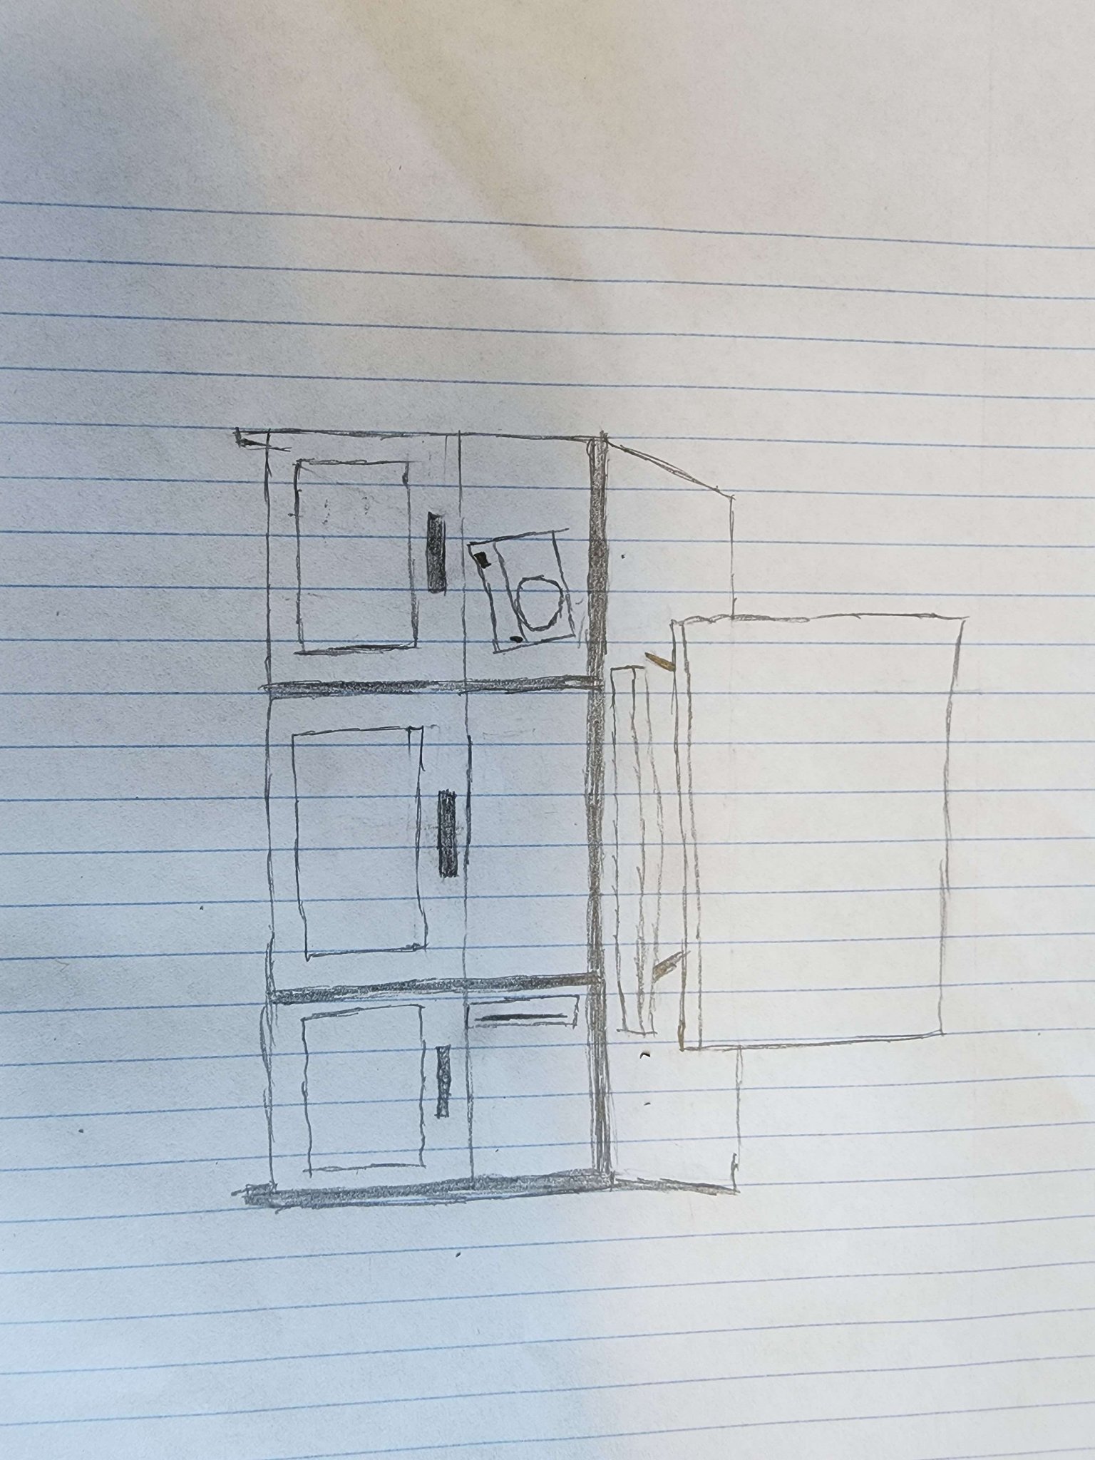 Original Hand Drawn